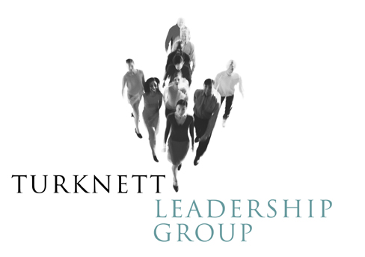

Decent People, Decent Company

News

Decent People, Decent Company was one of the five top sellers at the national Society for Human Resource Management’s (SHRM) bookstore in April. The book is now in it’s second printing and continues to be a strong seller in business books.

